**FSD LAB 2**

**DEV DESAI 1032211612 F29**

Aim: Design and develop a responsive web page using Bootstrap front end framework.

Objectives:

1. To understand HTML tags
2. To learn the styling of web pages using CSS
3. To learn Bootstrap Front End Framework.

Theory :

1. Bootstrap Grid System

Ans. The Bootstrap Grid System is a powerful and flexible layout system that is a core component of the Bootstrap front-end framework. It provides a way to create responsive and mobile-friendly web page layouts by organizing content into a grid of rows and columns. This grid system simplifies the process of designing and structuring web pages, ensuring that they look and behave well on various screen sizes and devices.

1. Bootstrap .container and .container-fluid class.

Ans. I).container:

* .container creates a fixed-width container for your content.
* It sets a maximum width for the content within it, ensuring that it doesn't become too wide on larger screens.
* The width of the container adjusts based on the screen size to provide a responsive design.
* Content inside a .container will have padding on the left and right sides to create spacing between the content and the edges of the container.
* It's suitable for most common web layouts where you want to control the maximum width of your content.

II) .container-fluid:

* .container-fluid creates a fluid or full-width container for your content.
* It stretches to occupy the full width of the viewport, making it ideal for designs that require content to extend from edge to edge.
* Unlike .container, .container-fluid does not have padding on the left and right sides.
* Content inside a .container-fluid will expand to fill the entire available width.

Output :

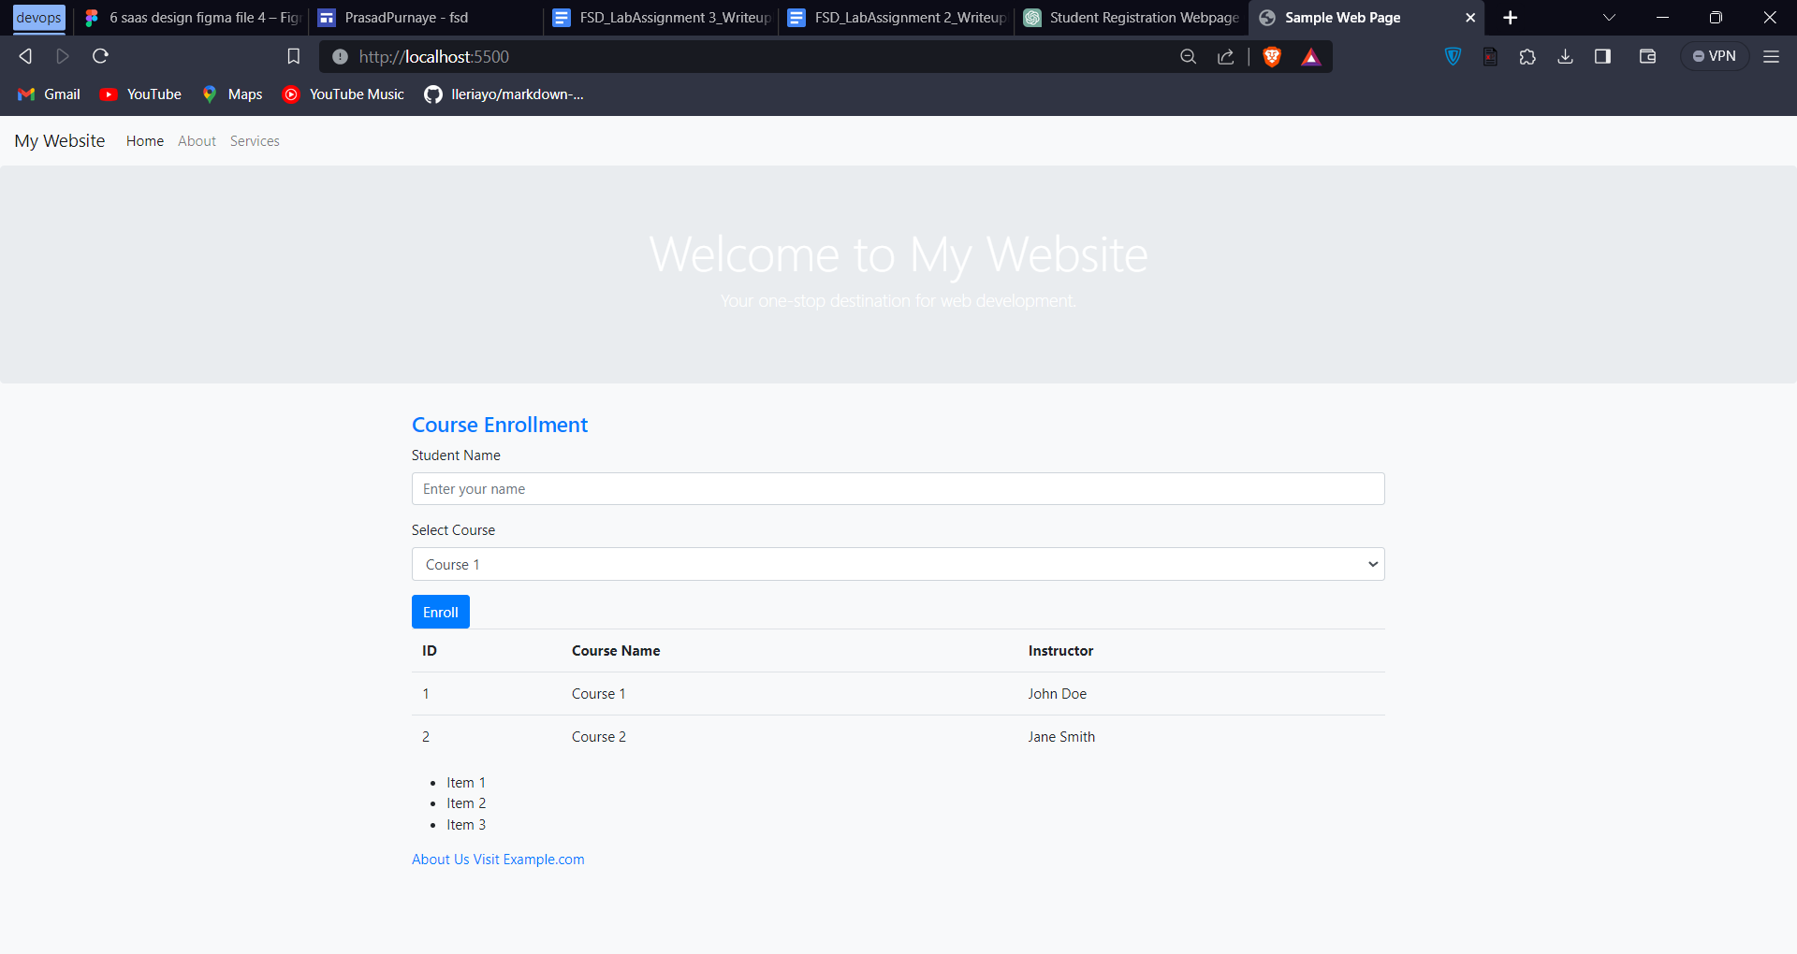

Code :

<!DOCTYPE html>

<html lang="en">

<head>

    <meta charset="UTF-8">

    <meta name="viewport" content="width=device-width, initial-scale=1.0">

    <title>Sample Web Page</title>

    <!-- Link to Bootstrap CSS (External CSS) -->

    <link rel="stylesheet" href="https://stackpath.bootstrapcdn.com/bootstrap/4.5.2/css/bootstrap.min.css">

    <!-- Internal CSS -->

    <style>

        /* Internal CSS for custom styling */

        body {

            background-color: #f8f9fa;

        }

        .container {

            margin-top: 20px;

        }

        .jumbotron {

            background-image: url('background.jpg');

            background-size: cover;

            color: #ffffff;

        }

        /* Custom class */

        .custom-heading {

            font-size: 24px;

            color: #007bff;

        }

    </style>

</head>

<body>

    <!-- Navigation Bar (Bootstrap) -->

    <nav class="navbar navbar-expand-lg navbar-light bg-light">

        <a class="navbar-brand" href="#">My Website</a>

        <button class="navbar-toggler" type="button" data-toggle="collapse" data-target="#navbarNav" aria-controls="navbarNav" aria-expanded="false" aria-label="Toggle navigation">

            <span class="navbar-toggler-icon"></span>

        </button>

        <div class="collapse navbar-collapse" id="navbarNav">

            <ul class="navbar-nav">

                <li class="nav-item active">

                    <a class="nav-link" href="#">Home</a>

                </li>

                <li class="nav-item">

                    <a class="nav-link" href="#">About</a>

                </li>

                <li class="nav-item">

                    <a class="nav-link" href="#">Services</a>

                </li>

            </ul>

        </div>

    </nav>

    <!-- Jumbotron (Bootstrap) -->

    <div class="jumbotron text-center">

        <h1 class="display-4">Welcome to My Website</h1>

        <p class="lead">Your one-stop destination for web development.</p>

    </div>

    <!-- Container (Bootstrap) -->

    <div class="container">

        <h2 class="custom-heading">Course Enrollment</h2>

        <!-- Form (Bootstrap) -->

        <form>

            <div class="form-group">

                <label for="studentName">Student Name</label>

                <input type="text" class="form-control" id="studentName" placeholder="Enter your name">

            </div>

            <div class="form-group">

                <label for="courseSelect">Select Course</label>

                <select class="form-control" id="courseSelect">

                    <option>Course 1</option>

                    <option>Course 2</option>

                    <option>Course 3</option>

                </select>

            </div>

            <button type="submit" class="btn btn-primary">Enroll</button>

        </form>

        <!-- Table (Bootstrap) -->

        <table class="table">

            <thead>

                <tr>

                    <th>ID</th>

                    <th>Course Name</th>

                    <th>Instructor</th>

                </tr>

            </thead>

            <tbody>

                <tr>

                    <td>1</td>

                    <td>Course 1</td>

                    <td>John Doe</td>

                </tr>

                <tr>

                    <td>2</td>

                    <td>Course 2</td>

                    <td>Jane Smith</td>

                </tr>

            </tbody>

        </table>

        <!-- List -->

        <ul>

            <li>Item 1</li>

            <li>Item 2</li>

            <li>Item 3</li>

        </ul>

        <!-- Links to other pages -->

        <a href="about.html">About Us</a>

        <!-- Link that opens in a new tab -->

        <a href="https://www.example.com" target="_blank">Visit Example.com</a>

    </div>

    <!-- Bootstrap JavaScript (Popper.js and jQuery are required) -->

    <script src="https://code.jquery.com/jquery-3.5.1.slim.min.js"></script>

    <script src="https://cdn.jsdelivr.net/npm/@popperjs/core@1.16.1/dist/umd/popper.min.js"></script>

    <script src="https://stackpath.bootstrapcdn.com/bootstrap/4.5.2/js/bootstrap.min.js"></script>

</body>

</html>